**Lab Practical #8:**

Study & Survey of Institute organization network infrastructure.

**Practical Assignment #8:**

1. **Identify type of network in your institute. Draw a design of network in your institute (Any Lab/Floor/Building).**

In our institute, the network infrastructure is mainly based on a **Local Area Network (LAN)**.  
The **LAN** is used to connect **computers**, **printers**, and **other** **devices** within the campus.  
Internet access is given through a central **router**/**gateway**, which is connected to the ISP. In some cases, **servers** are used to store files, manage logins, and control access.

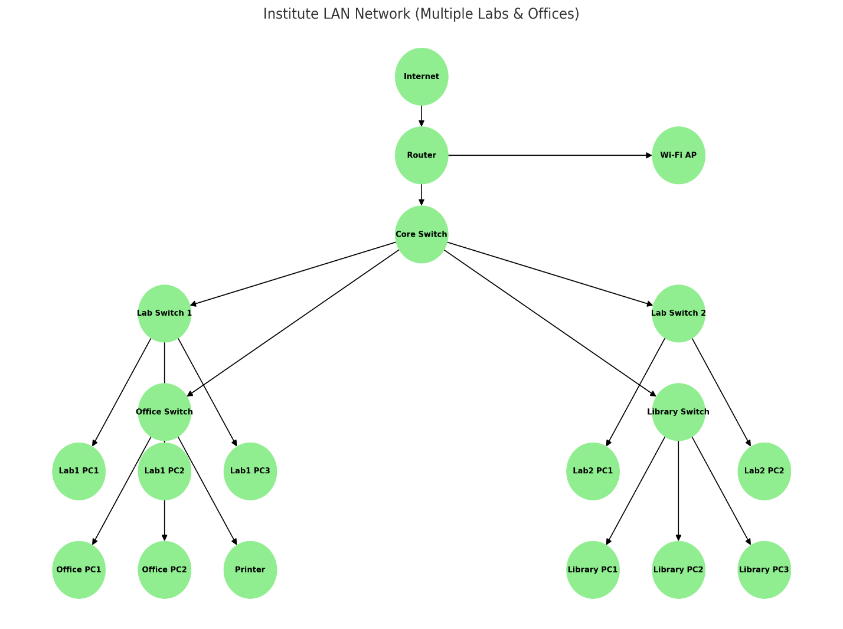

1. **List how many network devices and types of cable used and give its details.**

|  |  |  |
| --- | --- | --- |
| Device /Cable | Quantity | Details |
| Router | 1+ | Connects institute LAN to ISP/Internet. Provides routing, NAT, and firewall. |
| Core Switch | 1+ | |  | | --- | |  |  |  | | --- | | Central switch that connects to lab/office/library switches. | |
| Access Switches | 1+ (per lab/office) | |  | | --- | |  |  |  | | --- | | Connects PCs, printers, and devices within labs and offices. | |
| Desktop PCs | 50+ | |  | | --- | |  |  |  | | --- | | Used by students, faculty, and administration across labs, offices, and library. | |
| Printer | 5+ | Network-enabled, placed in labs, offices, and library. |
| Ethernet (Cat -6) Cable | Several (approx.100m) | |  | | --- | | Provides wired LAN connectivity between devices and switches. | |
| Wi-fi Access Point | In each LAB’s, Offices | |  | | --- | |  |  |  | | --- | | Provides wireless Internet for laptops, mobiles, and laptops. | |
| Server | 1 | Stores institute data, applications, and resources. |
| Projectors | 1  (per auditorium/lab/classroom) | Used for teaching with Internet-enabled presentations. |